

**Can’t I get**

**Type to Learn 4?**

**Everybody has it!**

This time it’s true. Everyone DOES have it!

Ridgefield Public Schools has purchased Type to Learn 4 and you can download it to your home computer. Simply follow the directions on the back of this page.

Keyboarding skills are a necessity for today’s students in the classroom and throughout their lives. The new Common Core State Standards assessments will be administered on the computer. Students need instruction and practice to develop ergonomic technique, accuracy, speed, and confidence to use the keyboard effectively. Type to Learn 4 provides that instruction and practice through skill lessons and fun practice activities. Ridgefield Public Library has added the program to the computers in the children’s section and you can download the program to any home computer. Get a head start on next year’s lessons at home this summer.

Our goals for students are as follows:

|  |  |
| --- | --- |
| **By the end of…** | **Students should complete lessons and assessments:** |
| Kindergarten | Lessons A, B, 1, 2 |
| First Grade | Lessons 3, 4, 5, 6, 7, and assessments 1 and 2 |
| Second Grade | Lessons 8, 9, 10, 11, 12 and assessment 2 |
| Third Grade | Lessons 13, 14, 15, 16, 17, 18 and assessment 4 |
| Fourth Grade | Lessons 19, 20, 21, 22, 23 and assessment 5 |
| Fifth Grade | Lessons 24, 25, 26, 27, 28 |

Please contact me if you have any questions:

Holli Levy

Elementary Technology Integration Teacher

Ridgefield Public Schools

hlevy@ridgefield.org

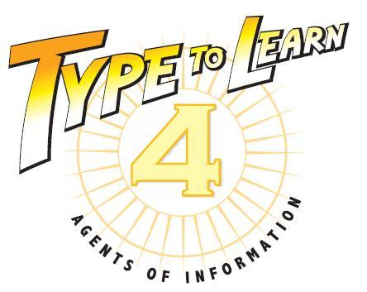

To download Type to Learn 4 please visit the website:

[**http://ttl4.sunburst.com/downloads/**](http://ttl4.sunburst.com/downloads/)

**Windows Users:**

Once you have entered the link above into a web browser you will select the “Windows MSI” file under “Full Versions”. “Full TTL4 v.1.2.1 Application MSI – WIN – Web Version (1.01GB)”. Choose “SAVE” rather than “OPEN” or “RUN”. Double-click the file when it has completed downloading and wait until it finshes installing. Once installed, launch the program by clicking the “Type to Learn 4” icon on your desktop.

**Macintosh Users:**

Once you have entered the link above into a web browser, other than “Safair”, you will scroll down to “Full Versions” and select the “Full TTL4 Application – Mac – Web Version v1.2.1 (994.65MB)” file. These files are zipped and should automatically unpack on almost all OSX operating systems. Launch the installer by double-clicking on the contained file in your ‘downloads’ folder. The contained files will be in MPKG format for installation to the Mac OS.

When you first open the program enter the username (no password for students). Then enter the following account code (code only necessary the first time the program is used on a computer):

146404

Download times vary greatly, but may take approximately 30 minutes or longer, depending on the speed of your connection.